FBL5N -

Functionality
Every time you post a customer document, the system automatically updates the relevant Customer account and GL reconciliation account. You can display & change documents posted to a particular account, also parked documents, noted items and documents posted with special GL indicators.
This document covers Customer Account Line Item Display. This report allows you to:
- Display and change line items,
- Print a report or export it in MS Office document formats (Excel or Word).

Scenario
You want to check and print customer account line items.

Requirements
Defined customer Master and previously posted documents.

Menu Path | Accounting → Financial Accounting → Accounts Receivable → Account → FBL5N - Display/change line items
Transaction Code | FBL5N

1. Double click on FBL5N - Display/change line items.

Customer Line Item Display

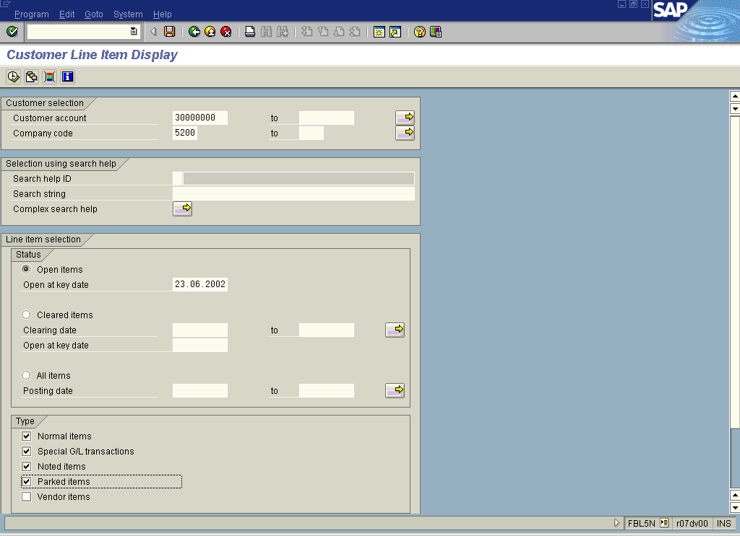

2. Update the following fields:

Field Name | Field Description | Values
Customer account | Code identifying a customer account | Example: 30000000
Company code | Code identifying a separate legal entity for which a separate set of accounts is maintained for external reporting purposes | Example: 5200

3. You can also display special GL transactions. Click Special G/L transactions .
4. The same way you can request to display parked documents and noted items. Click Parked items and Noted items

 You can display the following types line items:
- only open items (at particular date),
- only cleared items,
- items posted at a key date or within a specified period of time.

5. To display line items that fulfill previously entered criteria, press Execute :

Customer Line Item Display

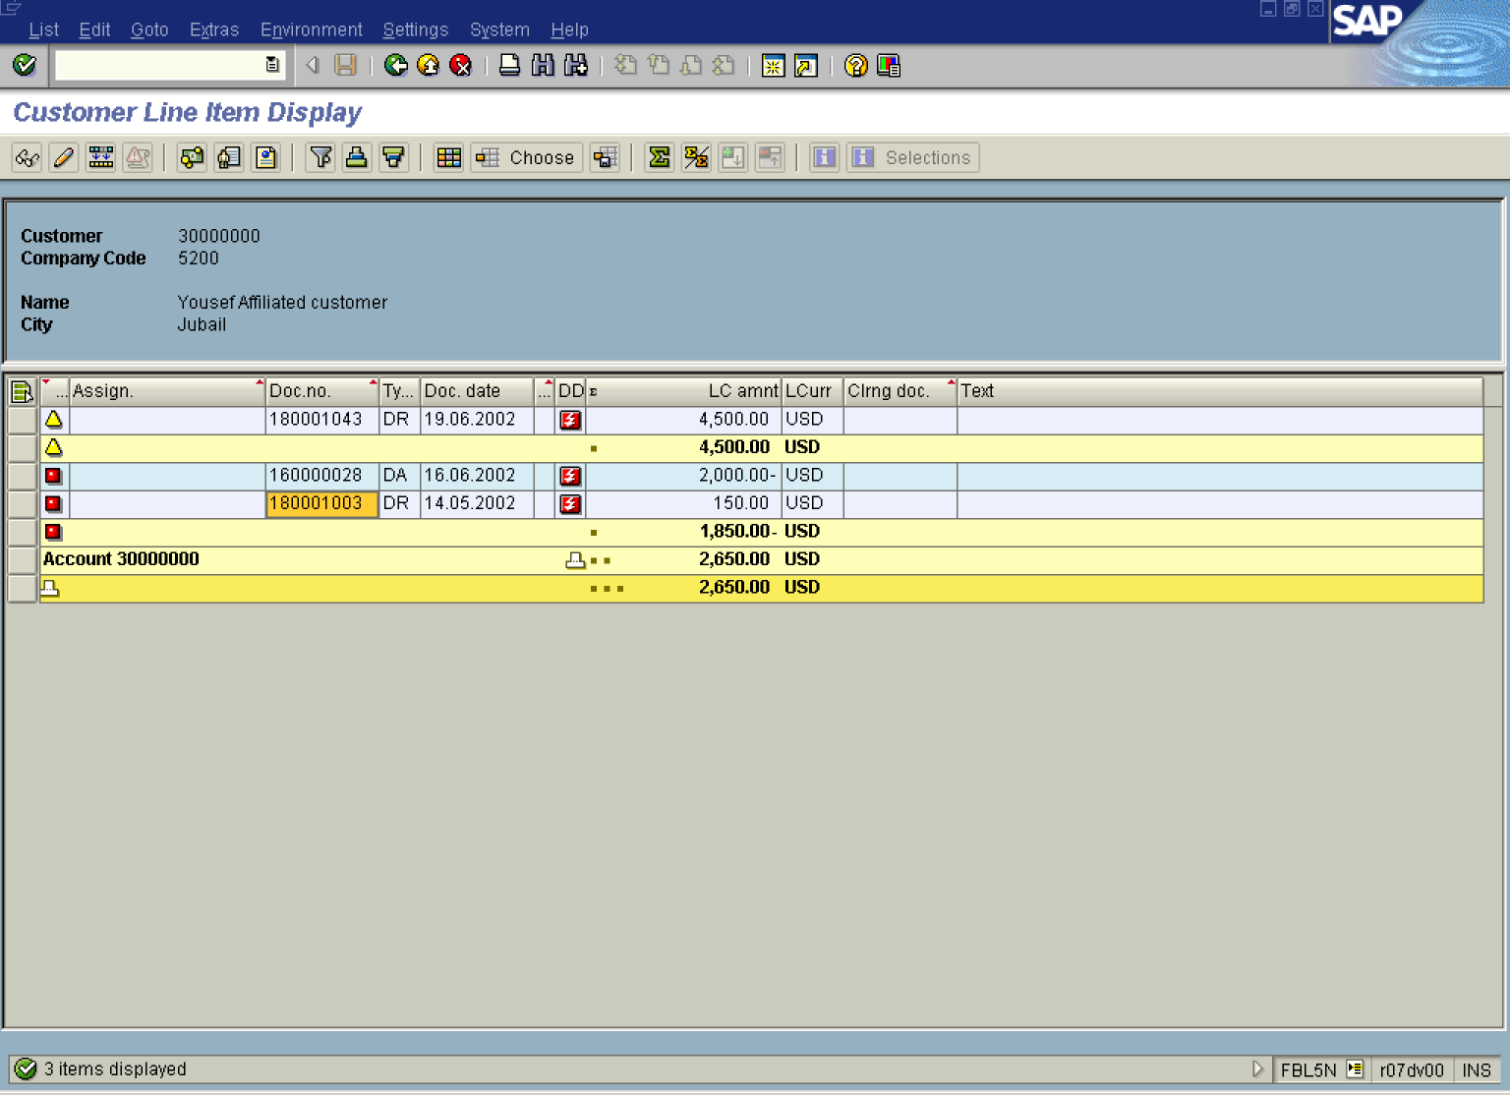

Tip: This report can be exported to MS Excel or MS Word. Select from menu path List -> Export -> Spreadsheet or Local file. The system will automatically open a requested MS Office application or create a file in a required format.

6. You can display document details you want to check. Simply double-click on the document number (e.g. 180001003):

Display Document: Line Item 001

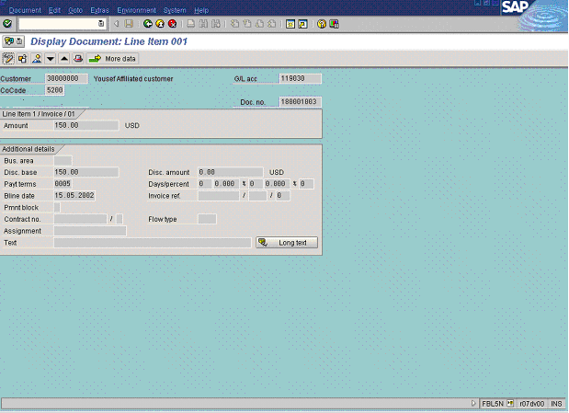

7. Some field in this document can be changed. To do so, click Display - Change Button . Fields that can be changed are highlighted in red:

Change Document: Line Item 001

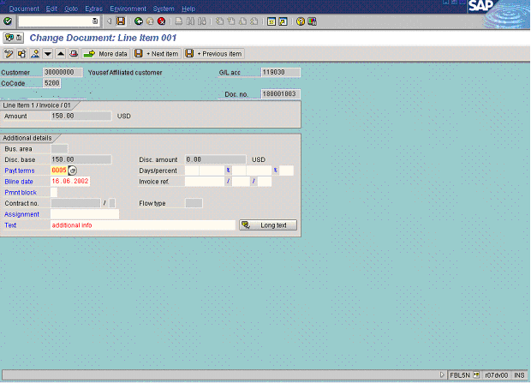

8. To change the line item, update the following fields:

Field Name | Field Description | Values
Bline date | Baseline date. This date indicates the beginning date to calculate payment terms from | Example: 16062002
Text | Additional document description | Example: additional info

9. Click Enter Button to confirm.
10. Click Save Button. to update the document.

11. The transaction “Customer Line Item Display” allows you to perform additional drill down reports:

Customer Line Item Display

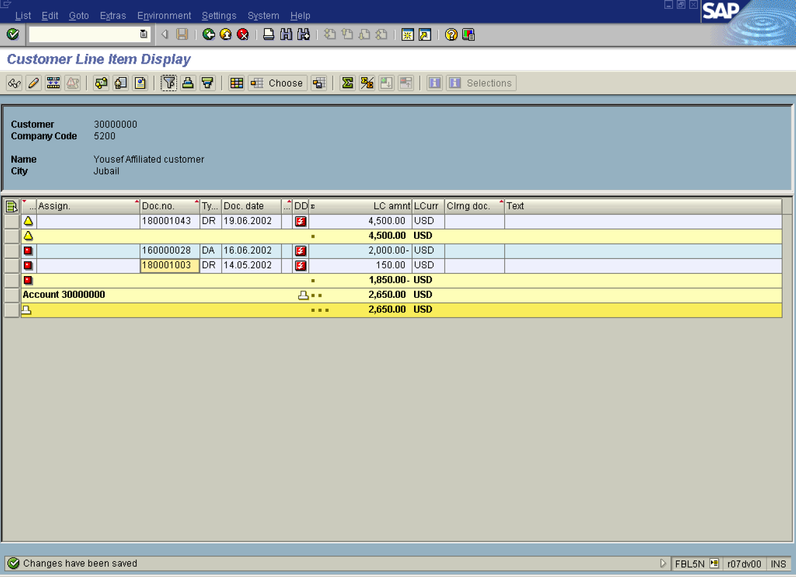

12. You can set “filter” to define additional search criteria for the line items. Click Set filter Button .

Define filter criteria

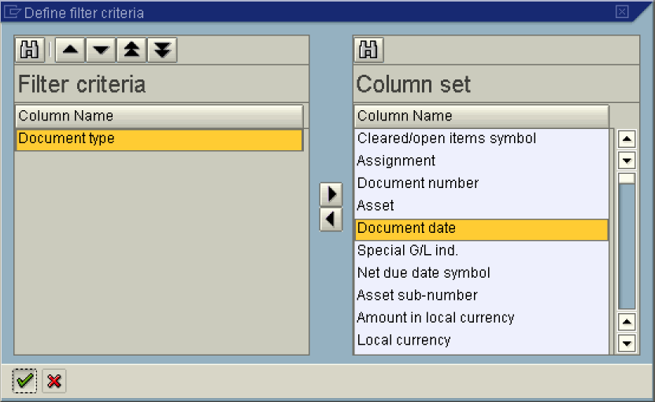

13. Let’s assume you want to display only the documents of a particular type. Select Document type in list box and press the arrow .
14. Click Enter Button . The system will display the screen where you can enter the types of documents you want to see on your report:

Determine values for filter criteria

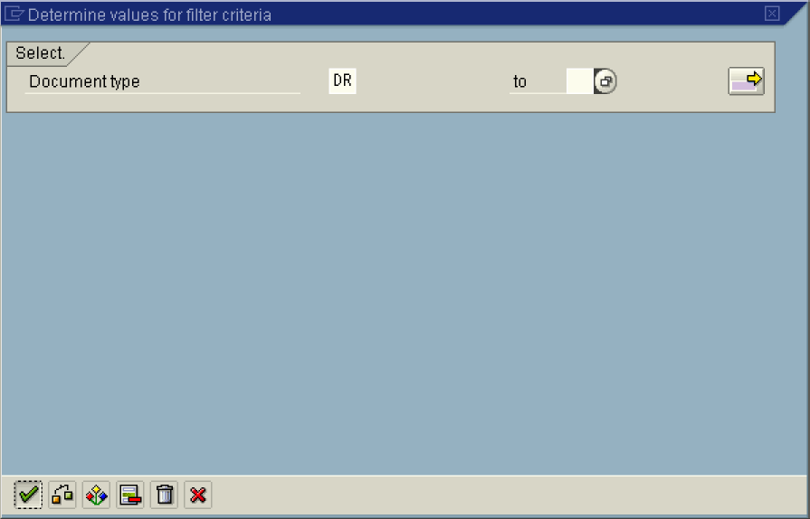

15. Update the following fields:

Field Name | Field Description | Values
Document type | Code identifying the method that the system uses to process the transaction | Example: DR

16. Click Enter Button . Now the system displayed only the documents type “DR”:

Customer Line Item Display

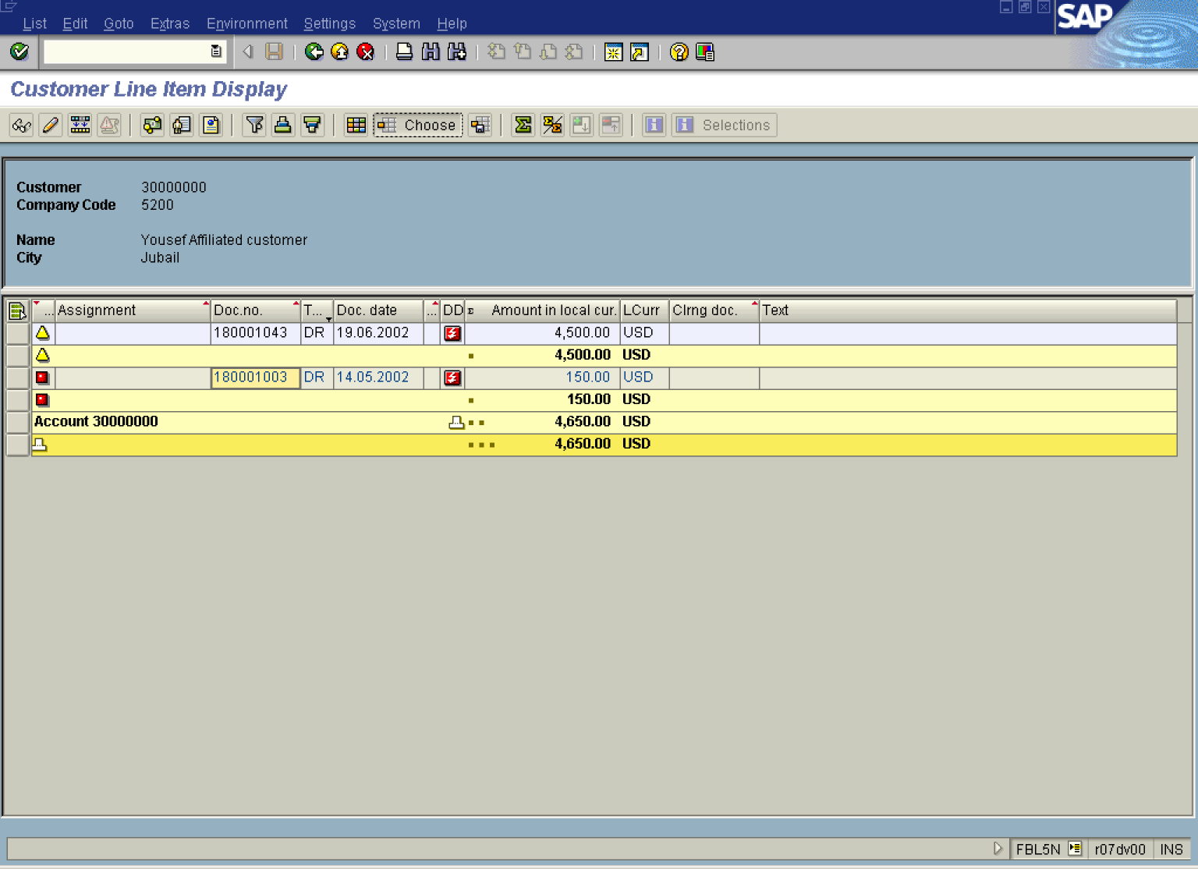

17. You can display the same report with different screen layout (different fields are displayed). Lets assume that you want to display this report, but you want to see the terms of payments for every line item. Click Choose Button .

Choose layout

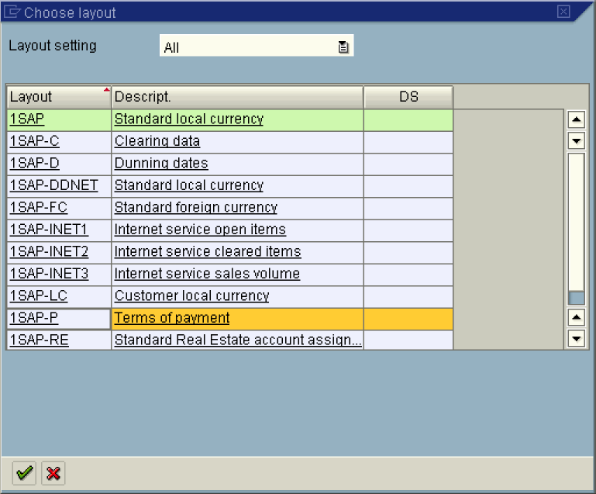

18. Mark your selection and click Enter Button :

Customer Line Item Display

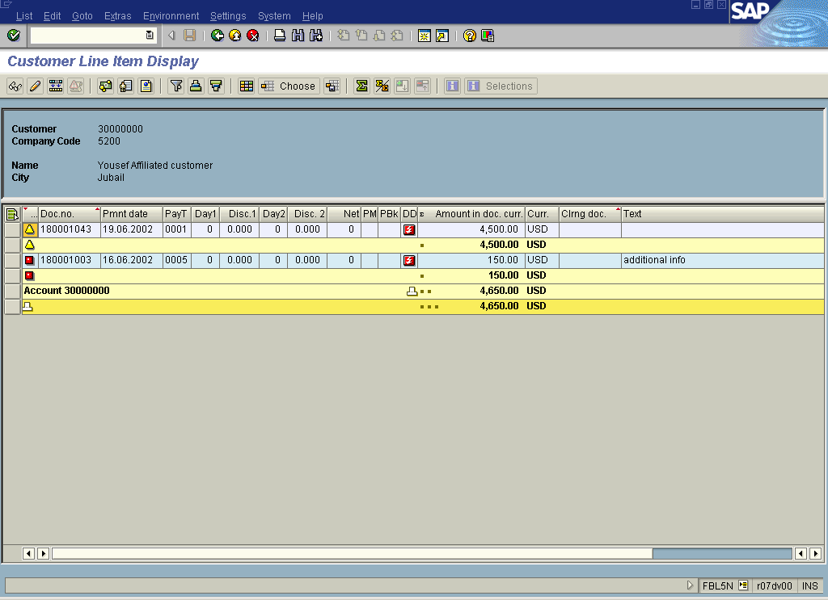

19. The system displayed the same documents, but you can see different fields, like e.g. payment date, payment methods etc.

